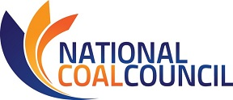

2020 SPRING ANNUAL MEETING
April 23-24, 2020 – Hyatt Regency, Bethesda, MD (Washington, DC Suburb)
NCC MEETING REGISTRATION
Fax: 732-231-6581 or Email info@NCC1.org this registration form.
Please register for the meeting no later than March 26th, 2020
Name:
Title:
Company:
Phone:
Address:
Email Address:
Guest Name(s):
Guest Company & Email:
I will attend the following events ~ Note: You will be invoiced for lunch, dinner, & sponsorships.
Thursday, April 23rd, 2020
_____ *NCC Reception 5:30-7:00 pm/Dinner 7:00-9:00pm
$145 individual seat ($75 government employee/spouse)
_____ *NCC Late Reception/Dinner Registration
($175 fee applies if you register after April 9th)
_____ Please reserve a priority dinner table of 8 for me @ discounted rate of $1000

Note: Counsel has advised that under House and Senate rules, this is a “widely attended event.” Under these rules, only NCC may extend invitations to House or Senate Members or staff to attend this event. Individual members of NCC are not permitted to extend invitations. Please contact the NCC office if you wish us to extend an invitation to Congressional members/staff on your behalf. Violations of these rules may result in criminal liability.
Friday, April 24th, 2020
_____ NCC Full Council Meeting 8:30 am-12:30 pm
_____ *Buffet Lunch Noon 12:30pm – 1:30 pm $50
*No refunds after April 9th. Refunds prior to April 9th subject to 5% service fee. *
Attention NCC Members: Travel reimbursement must be received by DOE no later than March 19, 2020.
Full details of the travel reimbursement policy may be found at
Travel Reimbursement Procedures for Qualifying NCC Members.
April 23rd NCC Reception/Dinner Sponsorship Opportunities

_____$3000 Coal Rocks Dinner Sponsor
- Three (3) seats at dinner w/priority seating (includes one seat at table w/keynote speaker).
- Company logo included on sponsorship banner and NCC website.
- Sponsorship acknowledgement on PowerPoint at NCC Full Council Meeting.
- Verbal recognition of sponsorship during dinner and at NCC Full Council Meeting.
- Sponsor Ribbon
_____$2000 Coal Rocks Reception Sponsor
- Two (2) seats at dinner w/priority seating (includes one seat at table w/keynote speaker).
- Company logo included on sponsorship banner and NCC website.
- Sponsorship acknowledgement on PowerPoint at NCC Full Council Meeting.
- Sponsor Ribbon
_____$1000 Coal Rocks Dessert Station Sponsor
- Acknowledgment as dessert station sponsor w/logo signage at dessert station.
- One (1) seat at dinner w/ priority seating.
- Company logo included on sponsorship banner and NCC website.
- Sponsor Ribbon

April 24th NCC Full Council Meeting Sponsorship Opportunities

_____ $ 2500 Event Sponsor
- Company logo included on sponsorship banner and NCC website.
- Special company write up distributed via web and at meeting.
- Sponsorship acknowledgement on PowerPoint at NCC Full Council Meeting.
- Sponsor Ribbon
_____ $1000 Keynote Session Sponsor
- Sign with company named displayed during keynote session.
- Company logo included on sponsorship banner and NCC website.
- Sponsorship acknowledgement on PowerPoint at NCC Full Council Meeting.
- Sponsor Ribbon
_____ $1000 Breakfast Sponsor
- Logo signs on breakfast station at Full Council Meeting.
- Company logo included on sponsorship banner and NCC website.
- Sponsorship acknowledgement on PowerPoint at NCC Full Council Meeting.
- Sponsor Ribbon
_____ $750 Break/Coffee
- Logo signs on the break station at Full Council Meeting.
- Company logo included on sponsorship banner and NCC website.
- Sponsorship acknowledgement on PowerPoint at NCC Full Council Meeting.
- Sponsor Ribbon
_____ $500 WIFI Sponsorship
- Company name featured on Full Council Meeting welcome PowerPoint.
- Company logo included on sponsorship banner and NCC website.
- Sponsor Ribbon
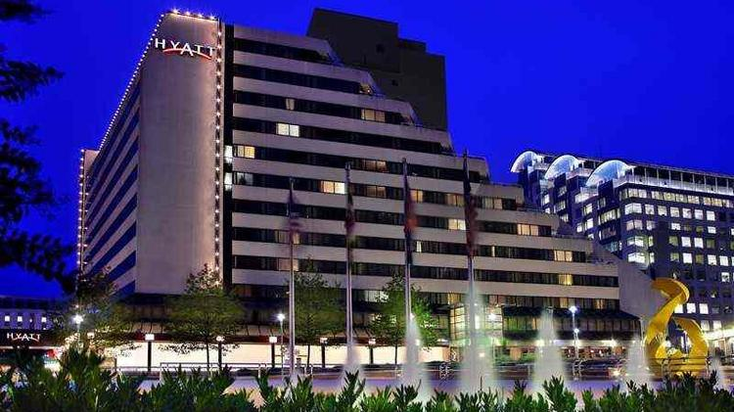
2020 SPRING ANNUAL MEETING
April 23-24, 2020 ~ Hyatt Regency Bethesda (Washington, DC Suburb)
Hotel Reservations
All events will be hosted at Hyatt Regency Bethesda
1 Bethesda Metro Center, Bethesda, MD 20814
Deluxe guest room rates are $199.00 per night
Reservations must be made by March 26th to secure this rate.
Rooms can be reserved by calling 301-657-1234 press 1 and requesting
National Coal Council 2020 Spring Meeting
For Online Reservations: https://www.hyatt.com/en-US/group-booking/BETHE/G-COAL

Disclaimers
Photo Release

The National Coal Council, its successors and assigns, retain the right and permission to publish, without charge, photographs taken during this event. These photographs may be used in publications, including electronic publications, or in audio-visual presentations, promotional literature, advertising, or in other similar ways. By attending the event, you agree to the foregoing.

Medical Release

Conference attendees acknowledge and agree that as a result of their registration and participation in the event, they hereby assume responsibility for their own well-being and safety. Attendees assume the risk in taking part in any voluntary off-site activities and attendees, their heirs, assigns and representatives hereby agree to indemnify and release the National Coal Council, its directors, officers, employees and agents from all liability, claims, demands or losses caused, in whole or in part, by attendee’s participation in the event or other activities including third party activities.

