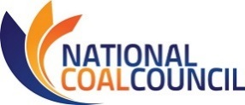
2018 ANNUAL FALL MEETING
September 12-13, 2018 – Hilton Norfolk The Main – Norfolk, VA
NCC MEETING REGISTRATION
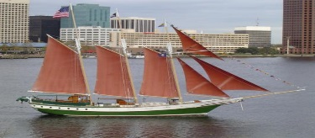
Fax: 732-231-6581 or Email info@NCC1.org this registration form.
Please register for the meeting no later than August 10, 2018
Name:
Title:
Company:
Address:
Phone/Email Address:
Guest Name(s):
Guest Company & Email:
I will attend the following events:
(You will be invoiced for lunch & sponsorships)

Wednesday, September 12th, 2018
_____ NCC Boat Excursion/Reception (Sponsored by Norfolk Southern) 6:00-8:00 pm

Thursday, September 13th, 2018
_____ NCC Full Council Meeting 8:30 am-11:45 am
_____ *Lunch 11:45 am - 12:30 pm $37
_____ Norfolk Southern Lambert’s Point Coal Export Terminal Tour 12:45 pm-4:00 pm

Sign Me Up for A Sponsorship!
_____Event Sponsor ~ $2500
_____Keynote Session Sponsor ~ $1000
_____Breakfast Sponsor ~ $750
_____Break/Coffee Sponsor ~ $750
_____Lunch Sponsor ~ $750

Transportation for the tour will be provided by National Coal Council. The bus will pick up from the hotel and drop off at the hotel after the terminal tour. Transportation to the airport must be arranged individually by each attendee.

*No refunds after August 29th. Refunds prior to August 29th subject to 5% service fee. *
Attention NCC Members: Travel reimbursement must be received by DOE no later than August 10, 2018.
Full details of the travel reimbursement policy may be found at
Travel Reimbursement Procedures for Qualifying NCC Members.
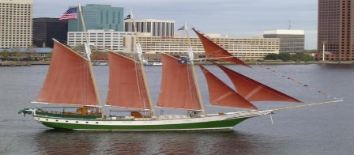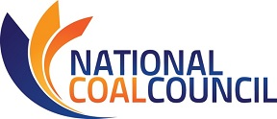
2018 ANNUAL FALL MEETING
September 12-13, 2018
Norfolk, VA

Hotel Reservations
The NCC Full Council Meeting will be hosted at the Hilton Norfolk The Main
100 East Main Street, Norfolk, VA 23510
Deluxe guest room rates are $179.00 per night
Reservations must be made by August 10th to secure this rate.
Rooms can be reserved by calling 1-866-238-4218 and requesting
National Coal Council 2018 Fall Meeting
For Online Reservations:
http://www.hilton.com/en/hi/groups/personalized/O/ORFWAHH-NNC-20180911/index.jhtml?WT.mc_id=POG

Know Before You Go!
Hilton Norfolk The Main is at the corner of Main and Granby streets, in downtown Norfolk, VA. Situated within walking distance to over 50 restaurants and 9 miles from Norfolk International Airport. Check in time is 4:00 pm and check out time is 11:00 am. The hotel offers self-parking for $20.00 and Valet Parking for $26.00. Upon check in you will notice an amazing art collection on every floor of the hotel. The hotel has 3 hip dining venues on-site, including Norfolk’s first roof garden and lounge, indoor pool and state-of-the-art 24-hour fitness center. From your room upon check in you will either have a view of the Elizabeth River or downtown Norfolk. I do hope you can join us!

NCC FULL COUNCIL MEETING FALL 2018
SPONSORSHIP OPPORTUNITIES

Sign Me Up for A Sponsorship
Fax: 732-231-6581 or Email info@NCC1.org this registration form.
(You will be invoiced for sponsorships)

Name:
Title:
Company:
____Event Sponsor ~ $2500
As the Event Sponsor you will have your company’s logo placed on the hotel key cards. These keycards will be given to everyone that checks in under our room block with your company’s logo on them! A brief company description in our Sponsorship Highlight packet will be distributed to every conference attendee. Your company’s logo will also be displayed on our Full Council Meeting PowerPoint and our Thank You Sponsors banner displayed outside of the entrance of the Full Council Meeting.

_____ Keynote Session (special acknowledgement at opening session) ~ $1000
As the Keynote Session Sponsor your logo will be placed front and center on an easel while the keynote speaker gives his/her speech at the Full Council Meeting. A brief company description will be placed in our Sponsorship Highlight packet that is distributed to every conference attendee. Your company’s logo will also be displayed on our Full Council Meeting PowerPoint and our Thank You Sponsors banner displayed outside of the entrance of the Full Council Meeting.

_____ Breakfast Sponsor ~ $750
As the Breakfast Sponsor your logo is displayed at the Full Council Meeting breakfast. This puts your company front and center with meeting attendees as they grab their morning breakfast. Your company logo is also displayed on the Full Council Meeting PowerPoint and Thank You Sponsors banner displayed at the entrance to the Full Council Meeting. A brief company description in our Sponsorship Highlight packet will be distributed to every conference attendee.

_____ Break/Coffee Sponsor ~ $750
As the Break/Coffee sponsor your logo will be displayed at every break during the Full Council meeting where you will host our coffee & snacks. Your company logo will be displayed on our Thank You Sponsors banner at the entrance to the Full Council Meeting and on the Full Council Meeting PowerPoint. A brief company description in our Sponsorship Highlight packet will be distributed to every conference attendee.

_____ Lunch Sponsor ~ $750
As the Lunch Sponsor your company will host our networking lunch. This lunch takes place immediately following our Full Council Meeting. Your company’s logo will be displayed in the lunch area. We will also highlight your company on our Full Council Meeting PowerPoint and our Thank You Sponsors banner displayed outside the entrance of the Full Council Meeting. A brief company description in our Sponsorship Highlight packet will be distributed to every conference attendee.

