Powering Economic Growth

The coal industry creates jobs for the American economy in three ways: by providing direct jobs to coal miners; by providing jobs in industries that support coal mining; and by providing reliable and low cost electricity that stimulates growth across the entire economy, especially in manufacturing.

Direct coal jobs
The coal industry employed nearly 74,000 full-time direct employees in 2014. Direct employees include those working at surface and underground mines, as well as at preparation plants and on-site offices. While these jobs themselves are important, the indirect effects of these jobs have a strong impact throughout the U.S. economy.

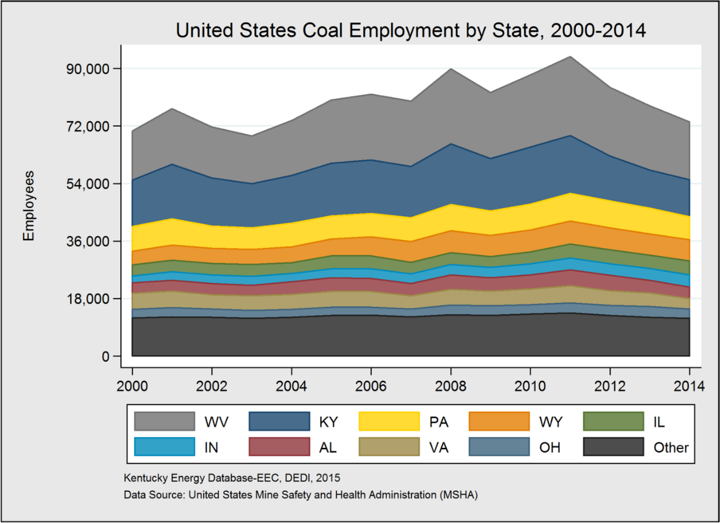

Related jobs
Additionally, nearly 83,000 related jobs were created as a result of the money spent by coal companies and their employees. This group includes others employed by mining companies in non-mining positions, such as engineers, lawyers and truck drivers. Related jobs also include those who are not directly employed by mining companies, but who provide services and goods for mining companies and their employees, such as food service workers, health care providers and truck drivers.

Manufacturing jobs
Coal also supports economy-wide job creation because most of the coal produced in the U.S. is used to generate low cost electricity within our borders. Affordable electricity is one of the most important elements of economic growth – both services and manufacturing are strongly impacted by the price of electricity.

Chart based on data from www.eia.gov/forecasts/aeo/pdf/appendix_tbls.pdf

One approach to estimating the value of coal-generated electricity is to calculate the cost of replacing it with another form of generation. Analyzing the levelized cost of electricity (LCOE) yields the ability to compare the cost of dispatchable electricity generating units. Due to the added cost of environmental controls for coal units, the recent decrease in natural gas prices and advances in natural gas combined cycle (NGCC) efficiencies, NGCC generation is currently the cheapest option, based on LCOE, for new large scale plants at a total levelized cost of $79/MWh. However, the cost to operate the current coal fleet is the total levelized costs minus the levelized capital cost, which amounts to about $35/MWh. When a new NGCC unit is built to replace a coal unit, electricity rates will increase by the difference, $44/MWh (because the total LCOE for NGCC power is $79/MWh, while the operating cost of the coal unit is $35/MWh).

Economists have repeatedly found that when electricity prices increase, employment decreases. Similarly, if electricity prices decrease, employment increases. In fact, the Kentucky Energy and Environment Cabinet found that with a 10% increase in the real price of electricity nationally, the U.S. would lose, or fail to create, over one million jobs and decrease annual Gross Domestic Product (GDP) by $142 billion.

The consensus among U.S. economists is that electricity price elasticity of employment coefficients are negative. International researchers using data from China, Mexico and Turkey have also found negative associations between electricity prices and indicators of economic growth. In 2014, the U.S. had over 12 million employees in the manufacturing sector; the security of these jobs relies on low cost electricity.

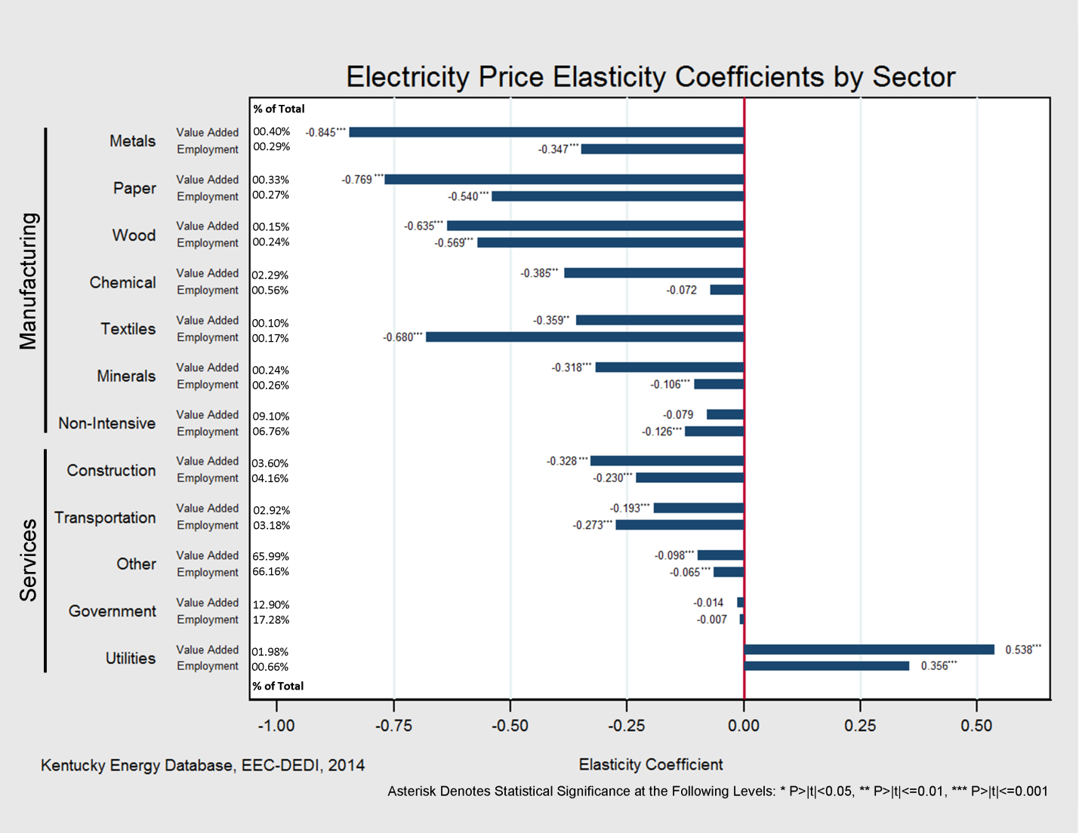
Elasticity coefficients in the graph indicate the effect of a 1% increase in electricity prices. If electricity prices rose 1% then employment in metal manufacturing employment would decrease by 0.347%. Source: 1.usa.gov/1aVhOWu

The big picture
In 2014, the coal industry employed directly, indirectly and otherwise created a total of 157,000 jobs. Coal has a long history of supporting employment and economic growth in the U.S. Since 1949, U.S. coal power plants have produced 75,640 terawatt-hours of reliable and affordable electricity with tens of thousands of coal miners working to supply them. Over the last several decades, nearly 50% of the total electricity produced in the U.S. has come from coal power plants – more than any other source.

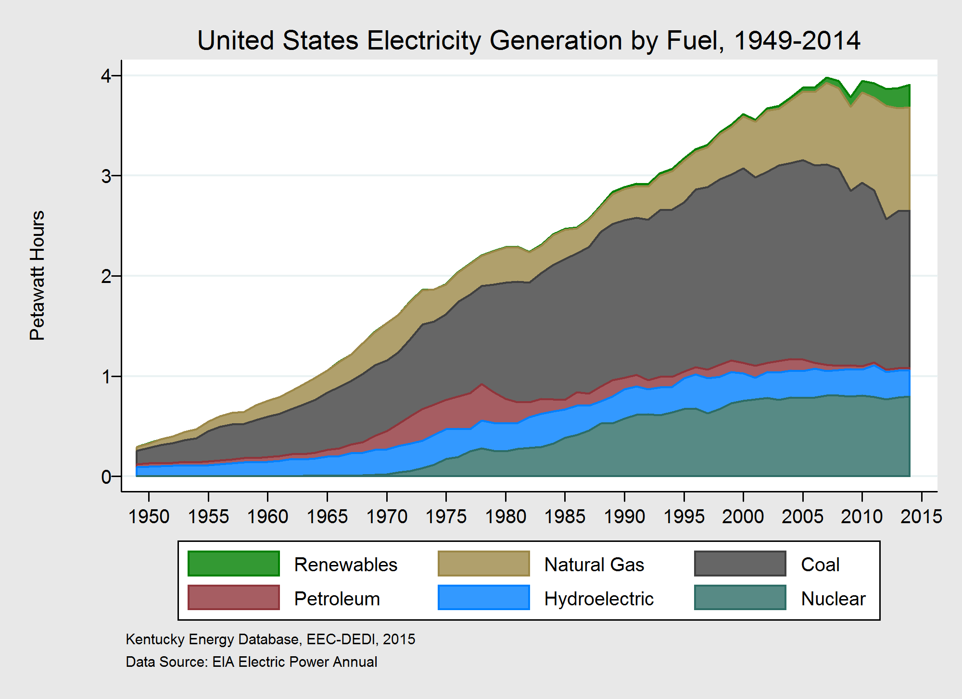

Engineers and industry professionals have trusted the electrical grid with coal generation for nearly a century precisely because it is affordable and reliable. Coal’s low-cost and abundance (U.S. has 26% of the world’s proven coal reserves) provides economic stability.

For More Information

Kentucky Coal Facts 15th Edition
energy.ky.gov/Pages/CoalFacts.aspx

The Vulnerability of the United States Economy to Electricity Price Increases 1.usa.gov/1aVhOWu

National Coal Council Studies
www.nationalcoalcouncil.org/page-NCC-Studies.html

EIA Electricity Data
www.eia.gov/totalenergy/data/monthly/index.cfm#electricity

International effects of increasing electricity rates - China
dx.doi.org/10.1016/j.enpol.2010.06.033
He, Y. X., S. L. Zhang, L. Y. Yang, Y. J. Wang, and J. Wang. "Economic analysis of coal price–electricity price adjustment in China based on the CGE model." Energy Policy 38, no. 11 (2010): 6629-6637.

International effects of increasing electricity rates - Mexico
www.jstor.org/stable/3440216
Sterner, Thomas. "Factor demand and substitution in a developing country: energy use in Mexican manufacturing." The Scandinavian Journal of Economics (1989): 723-739.

International effects of increasing electricity rates - Turkey
dx.doi.org/10.1016/j.eneco.2010.01.007
Bölük, Gülden, and A. Ali Koç. "Electricity demand of manufacturing sector in Turkey: A translog cost approach." Energy Economics 32, no. 3 (2010): 609-615.

Key Statistics
- Since 1949, U.S. coal-fired power plants have produced 75,640 terawatt-hours of reliable and affordable electricity, 49.4% of the total electricity produced in the U.S.
- In 2014, U.S. coal-fired power plants produced 1,586 terawatt-hours of electricity, 38.7% of the total electricity produced in the U.S.
- In 2014, 73,728 full-time workers were employed directly in the U.S. coal industry. An additional 82,915 related and indirect jobs are created as a result of the money spent by coal companies and their employees.
- With a 10% increase in the real price of electricity nationally, the United States would lose, or fail to create, over 1,000,000 jobs and decrease annual Gross Domestic Product (GDP) by $142 billion.
- Coal’s low-cost and abundance (U.S. has 27% of the world’s proven coal reserves) provides economic stability.

