

**Coal = Reliable Energy**

What makes a fuel source reliable? A combination of numerous factors. Is it secure and stable? Is it abundant? Is it widely available? Is it inexpensive and price-stable? Is it versatile?

**Coal is abundant**

Coal is the world’s most abundant energy resource. There are over [892 billion tonnes of proven coal reserves](http://www.bp.com/content/dam/bp/pdf/Energy-economics/statistical-review-2015/bp-statistical-review-of-world-energy-2015-coal-section.pdf) worldwide, enough to last nearly 110 years at current rates of production. In comparison, proven oil and natural gas reserves are equivalent to around 53 and 56 years, respectively, at current production levels. Reserves include only those supplies that are considered economically recoverable using current production technologies and costs. Coal resources, including all potential coal deposits, are about 17 times larger.

In the U.S., the [Energy Information Administration](http://www.eia.gov/) estimates that the demonstrated reserve base contains [480 billion short tons](http://www.eia.gov/coal/reserves/) (January 2014), noting that “coal resources are larger than remaining natural gas and oil resources”, based on energy content. The U.S. is rich in coal and has centuries of coal supply remaining at current production rates.

**Coal is widely available**

The [World Coal Association](http://www.worldcoal.org/) notes that there are [recoverable reserves of coal in almost 80 countries.](http://www.worldcoal.org/bin/pdf/original_pdf_file/coal_matters_2_-_global_availability_of_coal(16_05_2012).pdf) The largest reserves are located in the U.S., followed by Russia, China and India. Coal is actively mined in 70 nations, with 85% consumed within the country in which it is produced. Only 15% of coal is traded internationally.

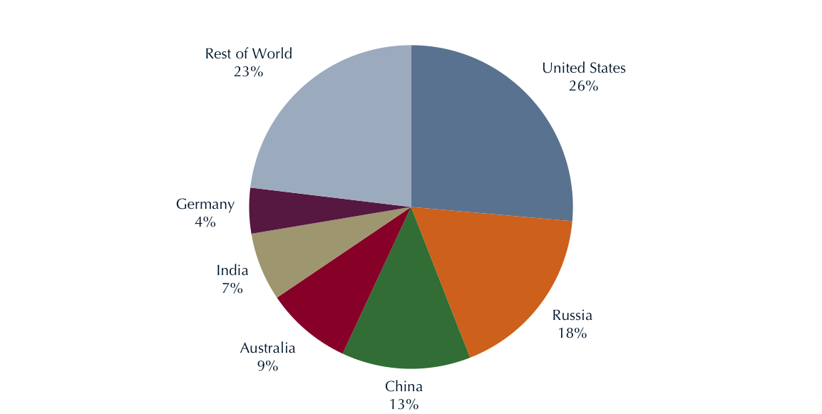

**Global Coal Resources**

Source: [U.S. Energy Information Administration, International Coal Statistics, 2011](http://www.eia.gov/cfapps/ipdbproject/IEDIndex3.cfm?tid=1&pid=1&aid=2)

Within the U.S., coal is the largest domestically produced source of energy. In 2013, coal was [produced in 24 states](http://www.nma.org/pdf/fact_sheets/cap.pdf) and consumed in the form of electric power generation in all but two states.

**U.S. Coal Resource Regions**

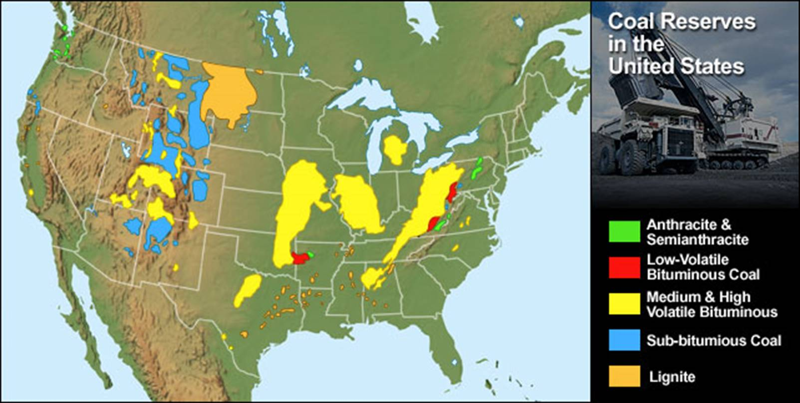

**Coal is a stable, secure energy source**

The interruption of energy supplies is disruptive to the health, well-being and economic prosperity of the world’s citizens. The ability to readily transport coal by ship, barge, rail and truck, without the need for pipeline infrastructure, contributes to coal’s supply stability. Coal also has the unique advantage of being able to be stored on-site, providing weeks or even months of fuel supply at the power plant. This important characteristic contributes to grid reliability, resiliency and reduces fuel supply bottlenecks. The importance of these qualities was made clear by the Polar Vortex, a severe cold snap in the U.S. that sent natural gas prices soaring and during which incremental demand was provided largely by [coal](http://www.nationalcoalcouncil.org/reports/1407/Existing-Coal-Fleet-Fact-Sheet-7-Polar-Vortex.pdf).

Unlike intermittent energy sources, such as wind and solar, coal generation can provide continuous baseload power. Hydropower, wind and solar power rely largely on weather factors outside of man's control.

Most of the world’s coal exports originate from countries which are considered to be politically stable, including the U.S., reducing the risk of supply interruptions. Consider, by contrast, that [over 53% of the world's natural gas reserves](http://www.worldcoal.org/bin/pdf/original_pdf_file/coal_matters_2_-_global_availability_of_coal(16_05_2012).pdf) are controlled by Russia, Iran and Qatar, while more than 50% of the world’s oil reserves are located in the Middle East. Coal-to-liquids (CTL) transportation fuels can serve as a hedge against the geopolitical risks associated with volatile oil suppliers; several such plants already exist in China and South Africa. The many benefits and uses of coal are the reasons that in 2014, worldwide production of coal was nearly 8.2 billion metric tons, about 11% of which was produced by the U.S.

**Coal is Inexpensive**

The cost of electricity is greatly influenced by the cost of fuel. Thus, low-cost fuel can be used to produce low-cost electricity, which acts as a stimulus to the economy, providing more disposable income to consumers and creating a competitive edge for U.S. manufacturers supplying global markets. Evidence of the value of the U.S. existing fleet can be seen in a visual [comparison of states](http://www.nationalcoalcouncil.org/reports/1407/NCCValueExistingCoalFleet.pdf) that have a large share of electricity generation from coal (top figure), with states that have low retail electricity prices (bottom figure).

Source of U.S. Electric Power (Data from DOE/EIA)

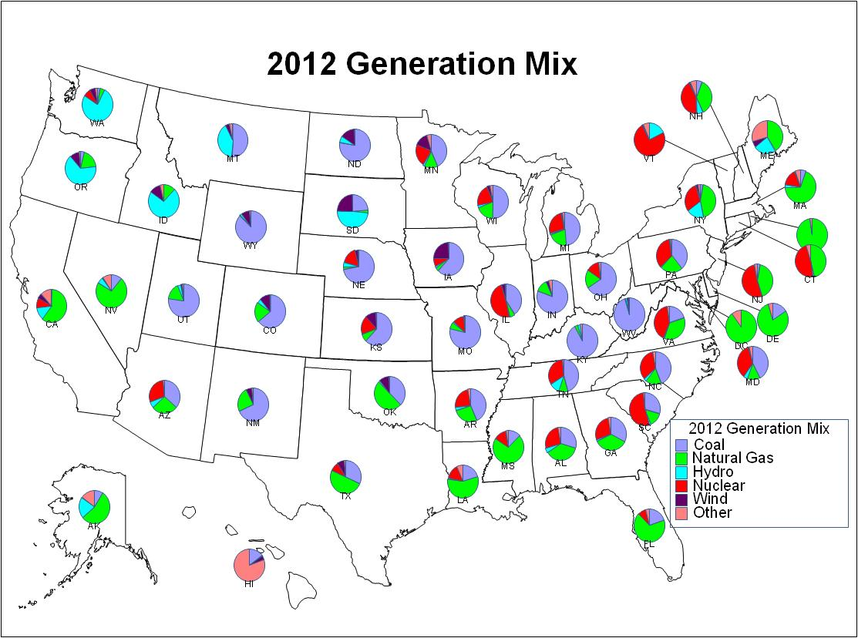

Average Retail 2012 Electricity Prices, by State (Data from DOE/EIA)

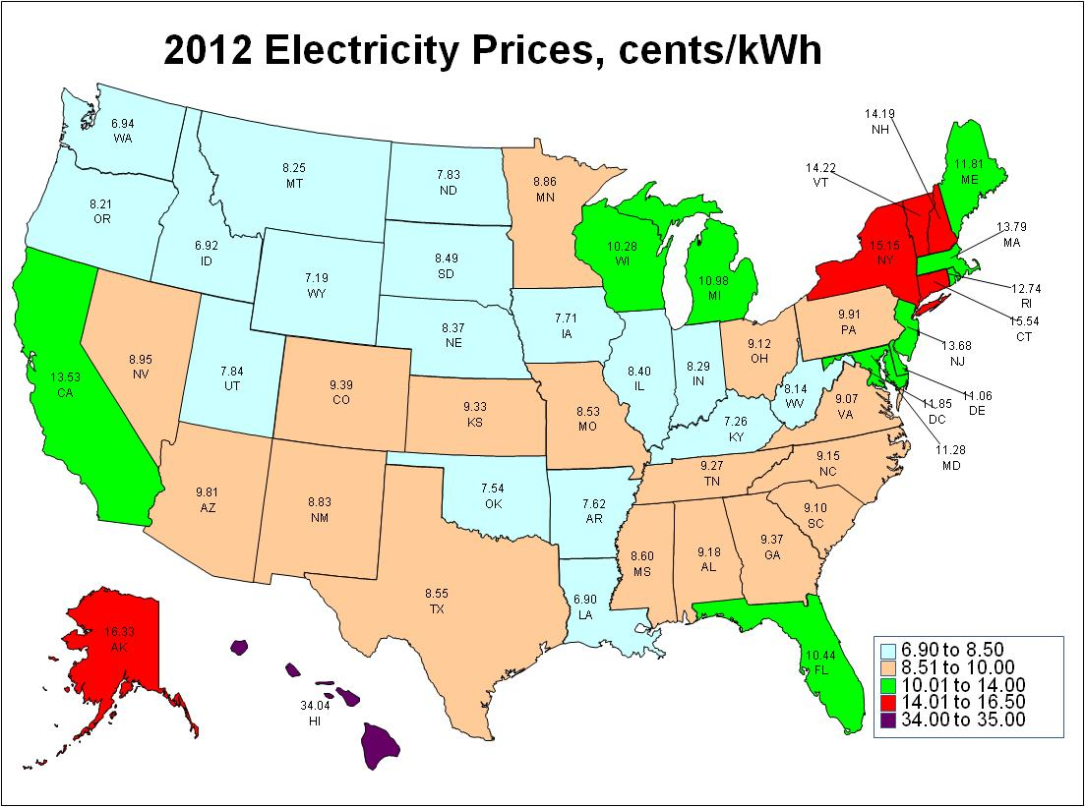

**The U.S. existing coal fleet continues to play a vital role in reliably meeting our nation’s electric power needs. The extreme cold weather events of the winter of 2013-2014 highlight the need to maintain a diverse portfolio of generation options in order to ensure the availability of affordable, reliable power for residential and industrial uses.**

**Learn more about the lessons learned from the Polar Vortex of 2014.**

Coal prices are also quite stable when compared with other fuel sources, most notably natural gas. In fact, coal has served as a crucial buffer to spiking gas prices.

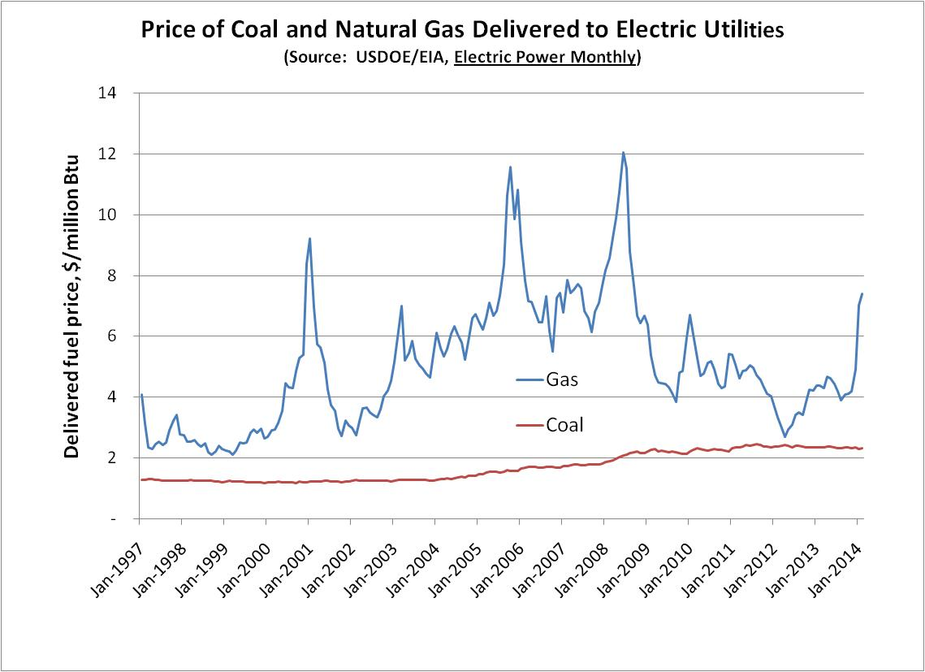

Coal fueled nearly 40% of the electric power in the U.S. during 2014, providing the nation’s citizens and businesses with affordable energy. In evaluating the [value of the U.S. existing coal fleet](http://www.nationalcoalcouncil.org/reports/1407/NCCValueExistingCoalFleet.pdf), the National Coal Council compared the price of electricity in the U.S. to that of other free market nations, noting that European power costs are two to three times those in the U.S.[1]

Electricity Price in 2013, Cents/kWh



**Coal is Versatile**

Coal provides 30% of global primary energy. It is used to generate 41% of global electricity. It is also used to [produce 68% of the world's steel](http://www.worldcoal.org/bin/pdf/original_pdf_file/coal_matters_4_-_coal_and_modern_infrastructure(01_05_2013).pdf) and is a key source of energy in energy-intensive industries, such as aluminum and cement production. The materials produced by these industries are necessary for construction, modern transportation, energy, housing and water management facilities.

Coal’s versatility is also demonstrated by the fact that it can contribute to the transportation sector. It can be used to produce [liquid transportation fuels](http://www.worldcoal.org/bin/pdf/original_pdf_file/wca151_coalmatters_6_final(13_05_2014).pdf), providing a viable alternative to conventional oil products and yielding fuels that are lower in sulfur, particulates and nitrogen oxides (NOx) compared to petroleum-derived fuels. Coal can also be used to support the electrification of the transportation sector through the use of coal-based electricity.

**Conclusion**

Coal passes the reliability test with flying colors. It is abundant. It is widely available. It is a stable and secure source of supply. It is inexpensive and price-stable. It is versatile. Coal = Reliable Energy.

**For more information**

National Coal Council Study – May 2014

[The Value of Our Existing Coal Fleet](http://www.nationalcoalcouncil.org/reports/1407/NCCValueExistingCoalFleet.pdf)

U.S. Energy Information Administration

[www.eia.gov/coal/](http://www.eia.gov/coal/)

International Energy Agency

[www.iea.org/](http://www.iea.org/)

World Coal Association

[www.worldcoal.org](http://www.worldcoal.org/)

**A Lesson from the Polar Vortex 2014**

[From the NCC's Value of the Existing Coal Fleet Study](http://www.nationalcoalcouncil.org/reports/1407/NCCValueExistingCoalFleet.pdf)

In January and February of 2014, the nation was swept with a series of cold weather events that tested the integrity of electricity supply. In general, electricity supply met demand, even under these severe conditions. However, electricity and gas prices surged for many consumers as energy supplies were stretched to their limits. More importantly, with increasing levels of coal retirements scheduled over the next three years (five times the level of retirements in 2012), it is clear that if those retirements had already occurred, the outcome would have been much worse.

**“This country did not just dodge a bullet – we dodged a cannonball.”**

**– Nick Akins, CEO**

**American Electric Power**

**Testimony before**

**Senate ENR Committee**

**"As demonstrated by cold snaps just this winter, natural gas prices are volatile and spike...This has an immediate adverse effect on consumer electric bills. Coal, and its stable price is a long-term proven hedge against natural gas volatility and is critical if we are to continue to provide affordable electricity for our members." John Novak, Director of Environmental Issues, National Rural Electric Cooperative Association**

During increased power demand for much of the U.S. in January 2014, for example, alternative fuels were significantly supply constrained and in the words of *The New York Times,* ["Coal [came] to the Rescue."](http://www.nytimes.com/2014/03/11/business/energy-environment/coal-to-the-rescue-this-time.html) Wind produced only 4.7% of the nation’s power while solar produced less than 0.2%. Nuclear provided only 5% of incremental “year-over-year” generation and hydroelectric output *declined* 13%. As natural gas supplies faltered, gas turbines were taken offline but gas prices still spiked from the Northeast through the South to the Midwest to the Northwest. In some areas gas to produce electricity was more expensive than liquid fuel, even though the price of oil for generation rose to over $400 per barrel. Public Service of New Hampshire resorted to burning jet fuel and for the U.S. as whole, oil accounted for more incremental year-over-year generation than did nuclear power.

As shown in the figure below, for the months of January and February 2014, compared to the same months in 2013 and 2012, coal was the leading source of electric power in the U.S. The figure below shows that, for the winter of 2014, compared to 2013, [coal-fueled generation provided 92% of that increase](http://www.eia.gov/electricity/monthly/current_year/february2014.pdf). Although demand for power was greater in 2014, generation by natural gas decreased, because natural gas was diverted to fuel residential heating needs and gas prices soared to over three times that of coal.

U.S. Electricity Generation for January & February, 2012-2014

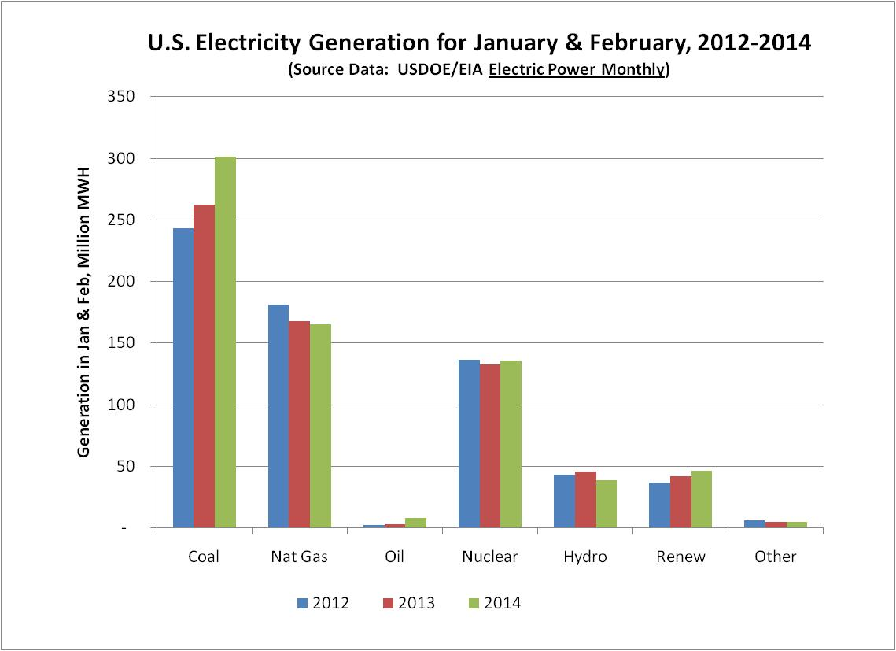

Portion of Increase in U.S. Electricity Generation, by Fuel

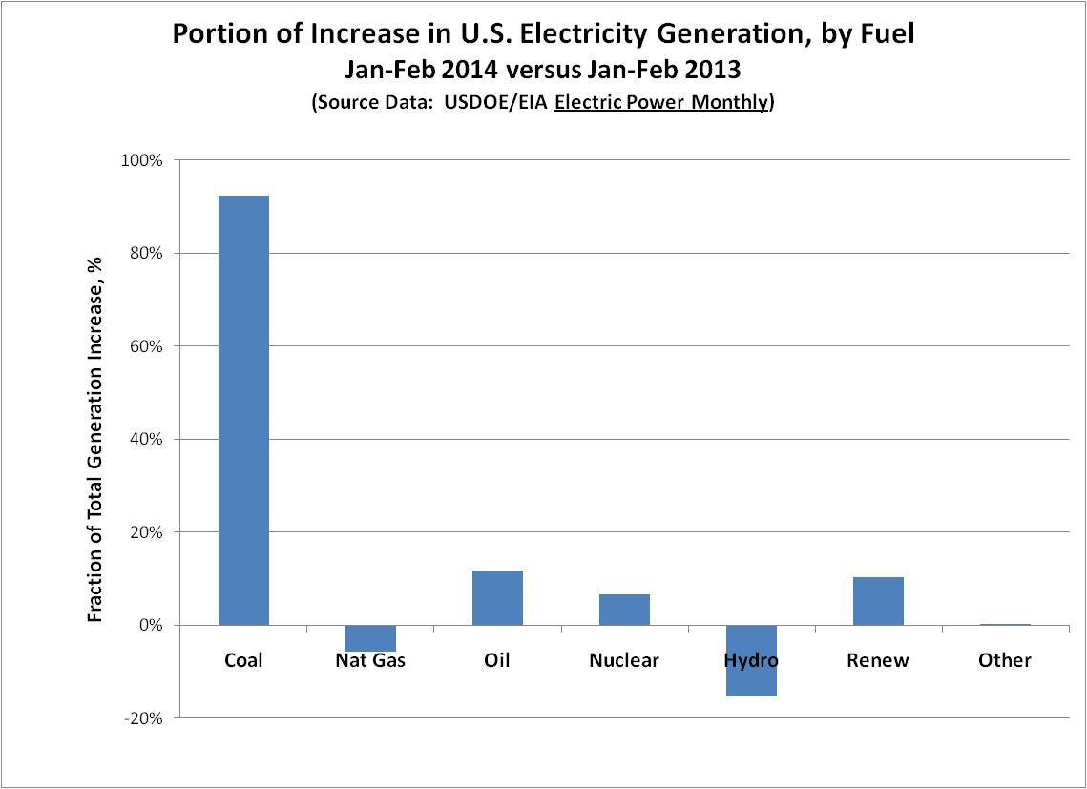

The U.S. coal fleet’s value has never been more apparent. Energy price spikes and supply problems in New England and throughout the nation during the winter of 2014, demonstrate the continued need for coal to ensure the reliability, affordability and security of America's electric supply system.

The major “lesson learned” from the Polar Vortex experiences in January and February of 2014 was that the U.S. power grid is less resilient than previously believed. Only the availability and operation of coal units now scheduled for retirement enabled the power sector to meet demand during periods of harsh weather events.

1. A significant part of the European Union (EU) price differential is believed to be based on taxes and fees levied in the EU to foster greater use of emerging renewable energy systems. These surcharges were estimated to total 20 billion euros in 2013. Die Welt, November 6, 2013. Additionally, the delivered price of coal and natural gas are generally 2-4 times as much as in the U.S. (Electric Power Monthly – March 2014, USDOE/EIA, March 21, 2014, [www.eia.gov/electricity/monthly/](http://www.eia.gov/electricity/monthly/); Statistical Review of World Energy 2013, BP, [www.bp.com/en/global/corporate/about-bp/energy-economics/statistical-review-of-world-energy-2013.html](http://www.bp.com/en/global/corporate/about-bp/energy-economics/statistical-review-of-world-energy-2013.html).)