Advancing Environmental Sustainability

The U.S. has been a global leader in minimizing the environmental footprint of coal from cradle to grave. In 2014, just under one billion tons of coal were mined in the U.S. At this rate, the country has over 250 years of recoverable reserves that can be used to meet the energy needs of today and tomorrow. Through application of existing and developing technologies, the environmental sustainability of coal can be continuously advanced.

After coal is produced, it is common practice to reclaim and restore mined lands and waters. Mined lands have been restored so they can be used for purposes such as building schools, airports, and recreational facilities as well as for industrial parks or agricultural uses. Since 1978, more than 2.7 million acres of mined lands in the U.S. have been restored to other beneficial uses.

Improving environmental performance
One of the industry’s environmental success stories has been the development and deployment of technologies to drastically reduce emissions from coal power plants. Since 1970, criteria emissions have decreased by ~80 to 90% for each kilowatt-hour (kWh) of electricity produced, while the total amount of electricity generation from coal has increased 183%.

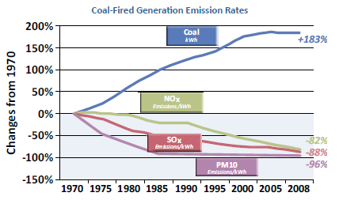
Source: energy.gov/sites/prod/files/cct_factcard.pdf

This remarkable drop in emissions was achieved as a result of the successful collaboration between the U.S. Department of Energy, technology developers, and industry, with 60% of funds ($1.95 billion) coming from the private sector.

Reducing carbon dioxide emissions
The latest environmental challenge is to reduce greenhouse gas (GHG) emissions produced during electricity generation. The National Coal Council has authored several studies on this topic in recent years. The first step toward a low-carbon future is the continued deployment of high-efficiency, low-emissions (HELE) technologies for coal power. About 50% of new coal power plants worldwide use HELE technology. If such technologies were implemented globally, the World Coal Association has estimated that the average global efficiency of coal- power plants would increase from 33% to 40%, enabling over two gigatons of CO₂ emissions to be eliminated each year.

For deep cuts in CO₂ emissions from coal power plants, carbon capture, utilization, and storage (CCS/CCUS) will be necessary. The technology is still in the early stage of deployment, but there have been notable early successes, the most prominent being SaskPower’s Boundary Dam Project. This CCS project has been operating since October 2014 and is capable of capturing and storing 1,000,000 metric tons of CO₂ each year. As a result, the plant produces only 25% of the emissions of a natural gas power plant.

Achieving climate goals
The U.S. is a global leader in the advancement of CCS. In fact, the majority of the operating large-scale projects are on U.S. soil, with more expected to come online soon. However, technology deployment must be accelerated in order for the world to meet long-term climate goals. Recently, the National Coal Council highlighted that CCS is the only large-scale technology that can mitigate CO₂ emissions from fossil fuel use, not just from electricity generation, but also from key industries, including cement production, iron and steel making, oil refining and chemicals manufacturing.

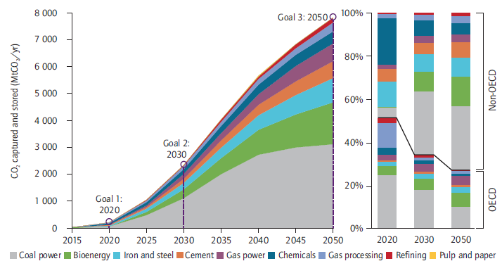

Not including CCS as a climate change mitigation technology is projected to increase the overall costs of meeting CO₂ emissions goals by 70%-138% globally. In a 2012 study, the National Coal Council found that using CO₂ from coal power plants for enhanced oil recovery (EOR) could generate nearly $200 billion in industry sales and create over 1 million jobs, while reducing the cost of carbon capture technologies. More recently, the National Coal Council has recommended that, recognizing the importance of CCS, greater policy parity is needed among low-carbon technologies

While the success demonstrated by advanced coal technologies can be used to mitigate emissions from continued reliance on coal worldwide, CCS must be rapidly deployed to meet international climate goals.

For more information
National Mining Association, Land Reclamation Information
www.nma.org/index.php/land/reclamation

U.S. Department of Energy Clean Coal Technology Demonstration Program Factcard
www.energy.gov/sites/prod/files/cct_factcard.pdf

Global CCS Institute, Resources
/www.globalccsinstitute.com/content/information-resources

Key Statistics
- Since 1978, more than 2.7 million acres of mined lands have been restored to other beneficial uses.
- Since 1970, criteria emissions have decreased by ~80 to 90% per unit of electricity, while electricity generation from coal has increased 183%.
- 60% of funds in the Department of Energy Clean Coal Technology Demonstration Program came from the private sector
- Boundary Dam has been operating since October 2014 and is capable of capturing and storing 1,000,000 metric tons of CO₂ each year, resulting in about one fourth the emissions of a natural gas power plant
- Not including CCS as a mitigation technology is projected to increase the overall costs of meeting CO₂ emissions goals by 70%-138% globally

