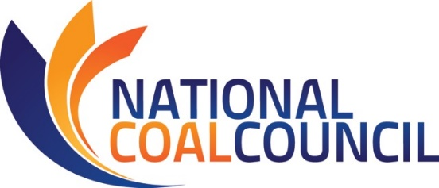

Enhancing Lives with Coal

“… between 1990 and 2010, about 830 million people – the vast majority in developing countries – gained access to electricity due to coal-fired generation. Indeed, roughly twice as many people gained access to electricity due to coal as due to natural gas; and for every person who obtained access to electricity over that period from non-hydro renewable sources, such as wind and solar, about 13 gained access to coal.”
~ Robert Bryce, Manhattan Institute ~ Not Beyond Coal

Coal is a significant global energy source. It is by far the world’s lowest cost major source of power and the most widely distributed geographically. For these reasons, coal will continue to be the global “go to” resource to increase modern energy access and enhance economic stability worldwide.
Life-enhancing electricity
Electricity is integral to almost all aspects of everyday life – including work, play, health care, safety and communications. The U.S. National Academy of Engineering ranked electrification as the “most significant engineering achievement of the 20th Century”. Today, more than 40% of all global electricity production comes from coal. Global coal consumption grew 60% from 2000 through 2012 and the International Energy Agency projects that coal will surpass oil as the top energy source worldwide by 2017.
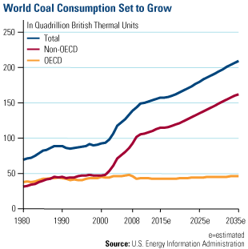

Modern energy services are crucial to human well-being and to a country’s economic development. The World Bank notes that for the 1.2 billion people that live without any access to electricity and the 2.8 billion that do not have access to clean cooking facilities, electricity offers a chance to live a healthier, more productive life.

Learn more about modern energy access needs in Africa.

The versatility of coal
In addition to generating electricity, coal also plays an important role in construction as an essential energy source for the manufacture of cement and steel. Today, 70% of the world’s steel is produced using coal; about 1.2 billion metric tons of coal were used for steel in 2013. The ability of coal to produce electricity, steel, cement, chemicals, fertilizers and other societal needs will play an increasingly important role as our global population continues to grow and urbanize.

The United Nations projects population increases through 2100; in fact, world population could conceivably double in the next two generations. These additional people will need more power, more food, more clean drinking water, and other basic requirements that coal can help provide.

Since coal is one of the least cost fuels, it also supports minority and low income households in maintaining an affordable source of electric power. In its Value of Our Existing Coal Fleet study, the National Coal Council noted the energy burdens of low income households are much higher than those of higher-income families. In other words, households with the lowest incomes have the highest relative energy costs. For a large percentage of households – mostly senior citizens, single parents and minorities – increased energy costs have forced hard decisions about what bills to pay: housing, food, education, health care and other necessities.

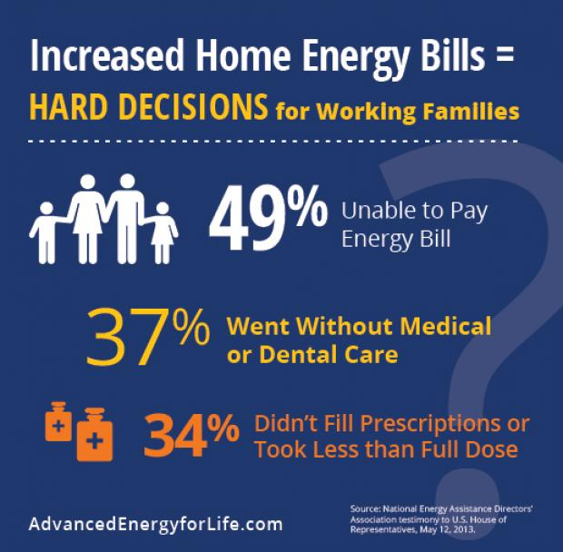

Coal’s global role
In its Fossil Forward study, the National Coal Council noted another important global phenomenon that will be aided by coal – the widespread acceleration of urbanization, largely occurring in non-OECD nations. Urbanization is a means to improve quality of life by significantly reducing the physical and environmental impacts of energy poverty in rural areas, especially for the women and children who walk for hours each day collecting biomass for heating and cooking.

By 2050, about 70% of humanity will live in cities. Vast amounts of electricity, steel, cement, and other coal-intensive materials will be needed to support these urban concentrations; such needs will increase coal demand in the future.

Coal resources also play a positive role in global politics. The National Bureau of Asian Research notes that the availability of coal throughout the world fosters economic and geopolitical stability. Because it is more widely distributed than oil and natural gas, coal’s geopolitical role reduces rivalries over access to these other resources in some regions and decreases overdependence on a single energy supplier.
Shortly after the Russian invasion of Crimea in March 2014, Poland’s Prime Minister, Donald Tusk, said that his country will need more domestic energy to avoid the possibility that Russia will “blackmail” Poland on natural gas … and that it was time to begin the “rehabilitation” of coal as an energy source.

World Bank statistics highlight the principal role that coal plays in creating access to modern energy worldwide. Between 1990 and 2010, nearly 750 million people gained access to electricity from coal-fueled generation, more than 5 times that provided by non-hydro renewables.

Estimate of Global Population that Gained Access to Electricity
by Generation Type, 1990-2010
Coal | 747,386,770
Natural Gas | 539,492,724
Hydro | 229,250,458
Nuclear | 131,379,729
Non-hydro Renewables | 117,502,595
Oil | 0
TOTAL NEW ACCESS | 1,700,000,000
Source: World Bank/OECD.

Electricity access is associated with a measurable increase in life expectancy. Throughout the world, coal has brought economic prosperity and a higher standard of living to more people than any other source of energy. It will continue to do so for generations to come.

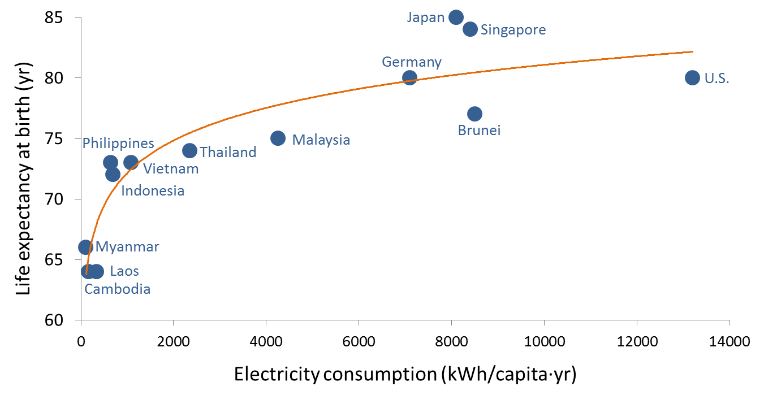
Source: cornerstonemag.net/asean-urbanization-and-the-growing-role-of-coal/

“The importance of coal in the global energy mix is now the highest since 1971. It remains the backbone of electricity generation and has been the fuel underpinning the rapid industrialization of emerging economies, helping to raise living standards and lift hundreds of millions of people out of poverty.”
~ Faith Birol, Chief Economist, IEA, In Cornerstone Magazine

For more information
National Coal Council Study – February 2015
Fossil Forward-Revitalizing CCS: Bringing Scale & Speed to CCS Deployment

National Coal Council Study – May 2014
The Value of Our Existing Coal Fleet

Peabody Energy
Advanced Energy for Life

Peabody Energy Video
What Powers Life in Just One Day

Manhattan Institute
Not Beyond Coal: How the Global Thirst for Low-Cost Electricity Continues Driving Coal Demand

International Energy Agency – World Energy Outlook
Modern Energy for All
Key Statistics

- Annual Per Capita Electricity Consumption (k/Wh/capita/year)
(CIA World Factbook)
Global Average = 3,000 kilowatt-hours

Iceland 51,478
United States 12,280
Australia 9,590
South Korea 9,296
Germany 6,767
Japan 6,756
EU 5,962
Poland 4,038
China 3,477
Mexico 1,787
Vietnam 1,125
North Korea 713
Indonesia 629
India 572
Pakistan 363
Nigeria 117
Somalia 28

- Growth of Modern Energy Access
Between 1990 and 2010, the percentage of people living in sub-Saharan Africa who gained access to electricity increased from 23% to 32%. Electricity access in southern Asia during this same time grew from 52% to 75% and in southeastern Asia from 71% to 88%. South Africa increased electricity access from 65% to 83%; Vietnam from 88% to 96%; Indonesia from 67% to 94%. World Bank – global access to electricity grew from 76% to 83% with about 1.7 billion people gaining access to electricity.

- Energy Demand in non-OECD Asia
(in million tons of oil equivalent Mtoe)

1990 2011 2035 % Share 2011 % Share 2035
Total Primary Energy Demand 1,578 4,324 7,045
Coal 694 2,349 3,193 54 45
Oil 318 899 1518 21 22
Gas 69 337 899 8 13

Power Generation 328 1,667 3,250
Coal 226 1,299 1,994 78 61
Oil 45 43 17 3 1
Gas 16 131 190 8 10

Source: IEA, World Energy Outlook 2013, 616.

Modern Energy Access Needs in Africa

Most of the people in the world without access to modern energy are located either in developing Asia or sub-Saharan Africa.

In a special African Energy Outlook report, the International Energy Agency (IEA) noted that more than 620 million people in sub-Saharan Africa (two-thirds of the population) live without electricity, and nearly 730 million people rely on dangerous, inefficient forms of cooking. The use of solid biomass (mainly fuelwood and charcoal) outweighs that of all other fuels combined, and average electricity consumption per capita is not enough to power a single 50-watt light bulb continuously.

The IEA projects that one billion people will gain access to electricity in Africa by 2040, 950 million of them in sub-Saharan Africa; but population growth in sub-Saharan Africa and progress in other parts of the world means that the remaining global population without electricity access will become increasingly concentrated in sub-Saharan Africa – this figure reaches 75% in 2040, compared with half today. This projection indicates that current efforts to tackle this problem are set to fall well short of the goal of achieving universal access by 2030, the target of the Sustainable Energy for All initiative. Instead, a sobering 635 million people in sub-Saharan Africa are set to remain without electricity by 2030.

Population Without Access to Electricity by Sub-Region
In Sub-Saharan Africa in the New Policies Scenario

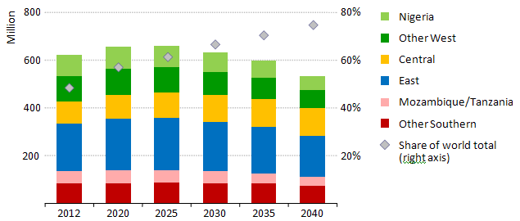

Demand for energy services by households across sub-Saharan Africa continues to rise along with incomes, but the fuel mix is relatively slow to change. Solid biomass is projected to still account for half of total end-use consumption in sub-Saharan Africa in 2040, this figure rising to almost 60% if South Africa is excluded from the estimate.

