Coal: Past, Present and Future

The use of coal as an energy source dates back to second and third century Rome, with archeological evidence suggesting it was mined from outcroppings and used as a heating source. By the 1700s coal was widely used because it burned cleaner and hotter than wood charcoal, helping to fuel the Industrial Revolution. Today, coal remains a primary energy source for electric power, accounting for 41% of global electricity generation. Developing nations, including China and India, are relying heavily on coal to support their growing economies – not just to meet rising demand for electricity but also for concrete and steel production – the building blocks of urbanization.

From the first lightbulb to the modern electric grid
Today’s modern coal power has its roots in the late 19th century when Thomas Edison invented the carbon filament light bulb as a replacement for smoke-emitting gas and oil lighting. In 1882, Edison opened the coal-fueled Pearl Street Station in New York City as the first permanent power station to provide electricity for lighting. Edison chose to put his power station in a densely populated area so he could serve as many residents as possible. With the introduction of alternating current (AC) by Westinghouse in the early 1900s, electric power could be transmitted over long distances, spurring the development of centralized power stations to serve population centers connected by transmission lines.

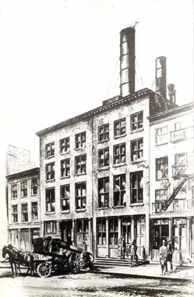
Pearl Street Station New York City

As steam turbine technology advanced, power stations became larger and more efficient, capitalizing on cost advantages from economies-of-scale. The fuel of choice for power plants during this period of early electrification was coal, due to its high energy content and abundance. The development of high voltage transmission technology allowed utility companies to connect multiple large coal power stations and deliver electricity to wide areas. Today, the U.S. electric grid still greatly resembles that transmission system backbone built during the mid-1900s around coal power. This is why coal is often referred to as the “backbone of the electric system.”

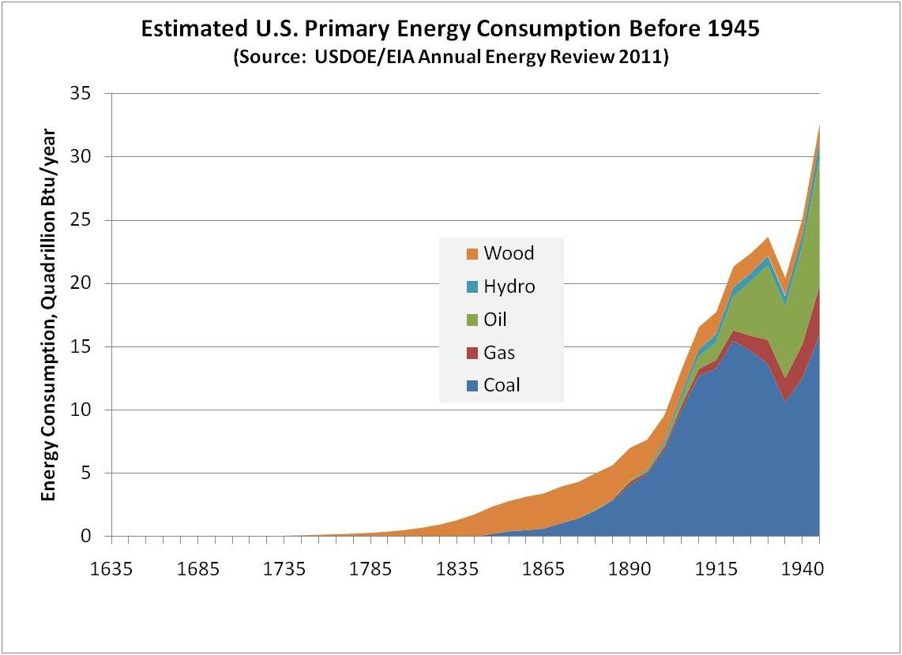

The use of coal in the U.S. grew with surging electric demand, increasing by an average annual rate of 3% from 1960 through 1990. But it was not until 2007 that coal consumption peaked in the U.S. Since that time, coal use for electricity generation has decreased as natural gas and renewable energy sources have been deployed. However, through 2014 coal still accounted for more kilowatt-hours generated than any other energy source. During the polar vortex of 2014, severe cold weather across the U.S. highlighted the value of the coal power fleet. During this time of great stress on the electric power grid when natural gas pipeline bottlenecks strained energy supplies, coal produced 92% of the increase in electric generation to meet the spike in demand.

Learn more about the role of coal during the 2014 Polar Vortex.

Coal – not just for electricity
In addition to electric power, coal is used for steelmaking and cement production. Coke, produced from coal, is used in blast furnaces for smelting of iron ore to produce molten iron, a primary component of steel. The molten iron is combined with scrap steel and a flux (usually limestone) in a basic oxygen furnace, producing pure liquid steel. Today, 70% of the world’s steel is made using coal. China uses more steel than any other country, accounting for 47% of global demand.

Cement is produced in kilns that use high carbon content fuels to heat raw materials and produce a pebble-like substance known as clinker. Clinker is combined with gypsum and ground into a fine powder that when mixed with water produces cement. Coal is one of the primary energy sources used in cement production, with about 390 pounds of coal needed for every ton of cement produced. China, India and the U.S. are the three largest producers of cement in the world. China’s cement production alone consumed 1.63 billion tons of coal in 2009.

Modern coal technologies to meet future demand
As coal became the fuel of choice for power generation, steam turbine technology advanced to utilize more of the thermal energy from combusting coal. Concurrently, technologies were developed to control the emissions from electric power generation. Coal power plants today produce 80 to 90% less particulate, sulfur oxides (SOx) and nitrogen oxides (NOx) emissions than just a few decades ago.

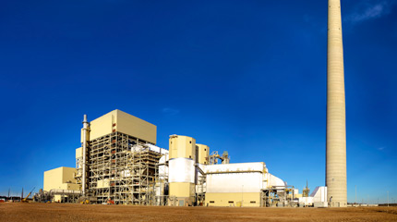
John W. Turk Plant, American Electric Power

In addition to emissions control systems, modern coal combustion technologies generate more power using less coal. These high-efficiency low-emissions (HELE) technologies can reduce carbon emissions by 20% for every kilowatt hour (kWh) generated. The world’s most efficient coal power plants, such as the John W. Turk plant in Arkansas and the Isogo Thermal Power Station in Japan demonstrate that meeting growing electric demand cost-effectively can be balanced with environmental and sustainability objectives. These power plants are based on ultrasupercritical coal technology, which generates very high steam temperatures and pressures, enabling them to be more efficient at converting thermal energy into electrical output.

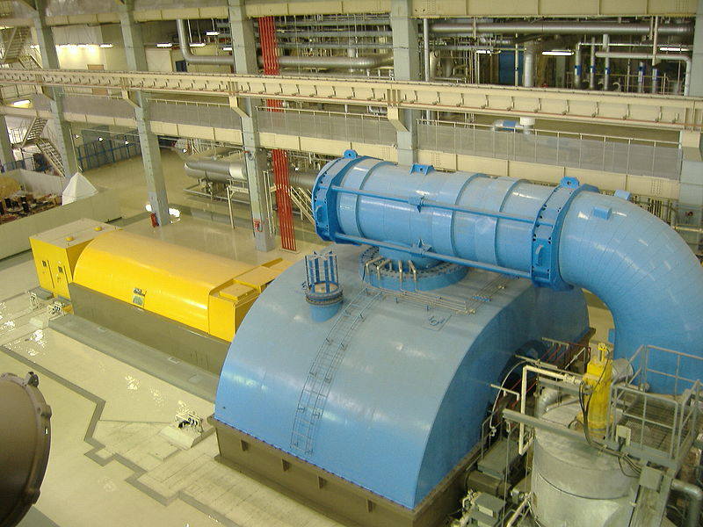
Isogo Thermal Power Station, Japan

The deployment of HELE coal technologies and carbon capture and storage (CCS) worldwide is important for lowering global carbon emissions. Emerging economies such as China and India are expected to drive a 15% increase in global coal demand through 2040. Despite recent retirements of numerous coal generating units in the U.S., domestic coal consumption is expected to remain steady through 2040 as coal continues to be a primary source of electricity.

In many countries – including the U.S. – electric power, steel production and cement manufacturing are inextricably linked with coal. The widespread availability and favorable economics of coal to meet future energy demand mean that coal will remain an important part of the global energy mix for decades to come.

For More Information
World Coal Association, Uses of Coal
www.worldcoal.org/coal/uses-of-coal/coal-electricity/

U.S. Energy Information Admininstrationwww.eia.gov/coal/data.cfm#consumption
www.eia.gov/electricity/data/browser/

SWEPCO, Turk Power Plant
www.swepco.com/info/projects/TurkPlant/

A Lesson from the Polar Vortex 2014
From the NCC's Value of the Existing Coal Fleet Study

In January and February of 2014, the nation was swept with a series of cold weather events that tested the integrity of electricity supply. In general, electricity supply met demand, even under these severe conditions. However, electricity and gas prices surged for many consumers as energy supplies were stretched to their limits. More importantly, with increasing levels of coal retirements scheduled over the next three years (five times the level of retirements in 2012), it is clear that if those retirements had already occurred, the outcome would have been much worse.
“This country did not just dodge a bullet – we dodged a cannonball.”
– Nick Akins, CEO
American Electric Power
Testimony before
Senate ENR Committee

"As demonstrated by cold snaps just this winter, natural gas prices are volatile and spike...This has an immediate adverse effect on consumer electric bills. Coal, and its stable price is a long-term proven hedge against natural gas volatility and is critical if we are to continue to provide affordable electricity for our members." John Novak, Director of Environmental Issues, National Rural Electric Cooperative Association
During increased power demand for much of the U.S. in January 2014, for example, alternative fuels were significantly supply constrained and in the words of The New York Times, "Coal [came] to the Rescue." Wind produced only 4.7% of the nation’s power while solar produced less than 0.2%. Nuclear provided only 5% of incremental “year-over-year” generation and hydroelectric output declined 13%. As natural gas supplies faltered, gas turbines were taken offline but gas prices still spiked from the Northeast through the South to the Midwest to the Northwest. In some areas gas to produce electricity was more expensive than liquid fuel, even though the price of oil for generation rose to over $400 per barrel. Public Service of New Hampshire resorted to burning jet fuel and for the U.S. as whole, oil accounted for more incremental year-over-year generation than did nuclear power.

As shown in the figure below, for the months of January and February 2014, compared to the same months in 2013 and 2012, coal was the leading source of electric power in the U.S. The figure below shows that, for the winter of 2014, compared to 2013, coal-fueled generation provided 92% of that increase. Although demand for power was greater in 2014, generation by natural gas decreased, because natural gas was diverted to fuel residential heating needs and gas prices soared to over three times that of coal.

U.S. Electricity Generation for January & February, 2012-2014
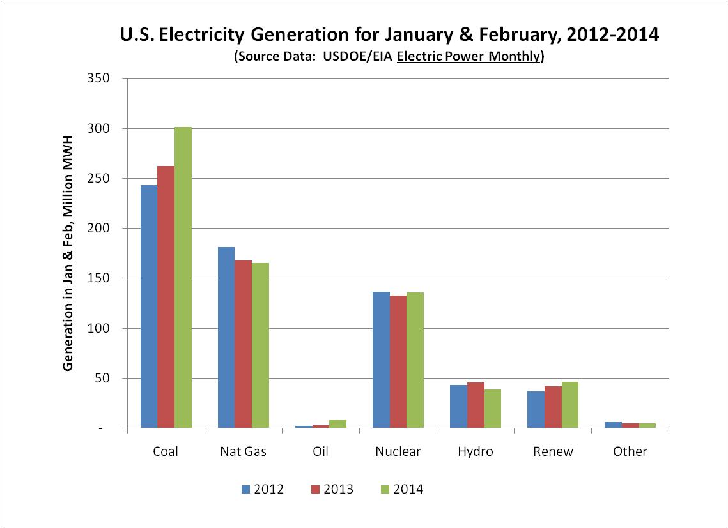

Portion of Increase in U.S. Electricity Generation, by Fuel
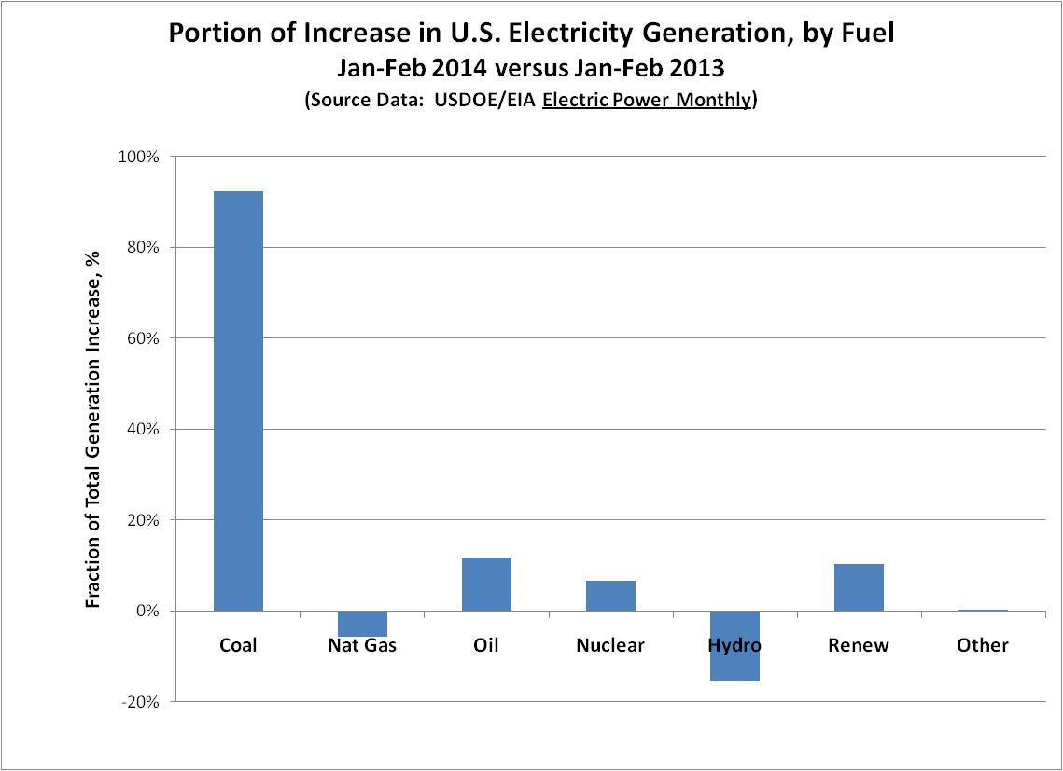

The U.S. coal fleet’s value has never been more apparent. Energy price spikes and supply problems in New England and throughout the nation during the winter of 2014, demonstrate the continued need for coal to ensure the reliability, affordability and security of America's electric supply system.

The major “lesson learned” from the Polar Vortex experiences in January and February of 2014 was that the U.S. power grid is less resilient than previously believed. Only the availability and operation of coal units now scheduled for retirement enabled the power sector to meet demand during periods of harsh weather events.

